# **CS 1101-01: Programming Assignment Unit 8**

Godknows Egi

Bachelor of Science in Computer Science, Uopeople

CS 1101-01 - AY2024-T3: Files

Bianca Gilyot

March 27th , 2024

**Question 1**

Write a program to read dictionary items from a file and then write the inverted dictionary to a file. Ensure the program includes the following components:

* The input file for your original dictionary (with at least six items).
* The Python program you used to read from a file, invert the dictionary, and write to a different file. (You need to create a dictionary file and invert it into another file).
* The output file for your inverted dictionary.
* Provide a technical explanation for the code and its output in a minimum of 200 words.

**Sample Input File (Not specific)**

{

apple: red

banana: yellow

cherry: red

mango: yellow

grapes: black, green

}

**Sample Output File:**

{

red: apple, cherry

yellow: banana, mango

black: grapes

blue: grapes

}

**Answer to question 1**

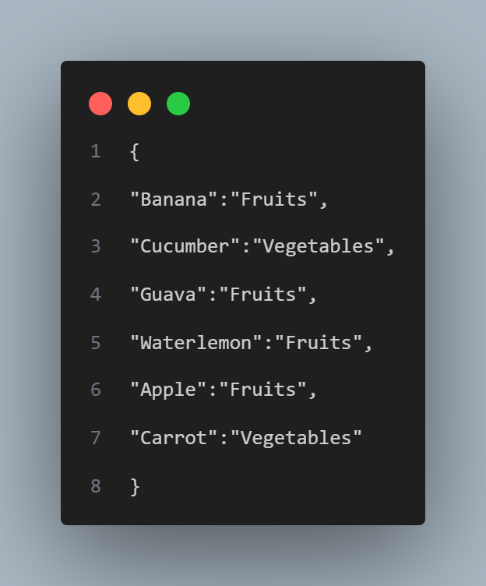

**Fig 1 *(input_file.txt)***

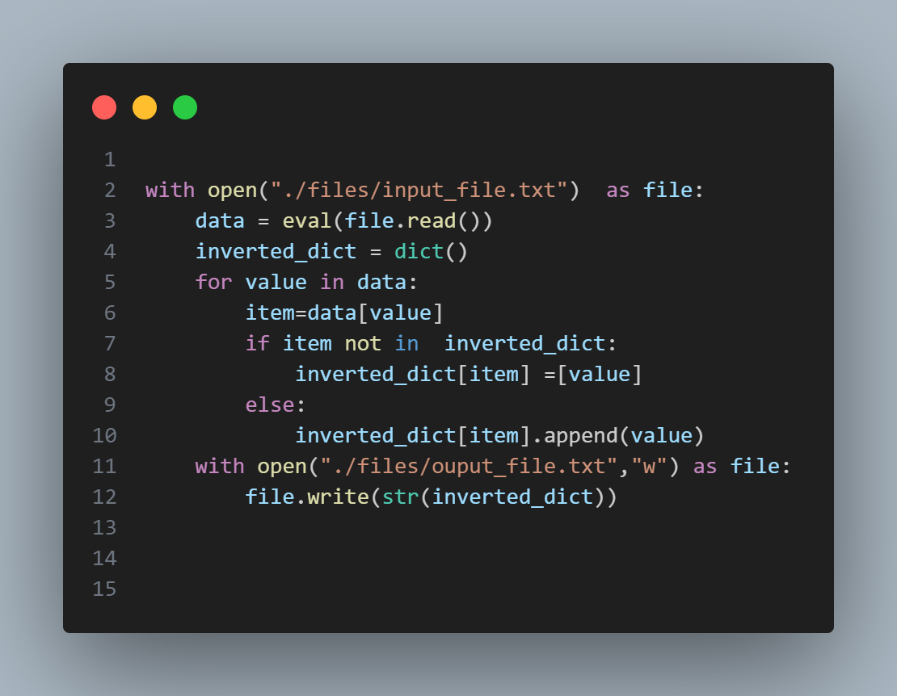

**Fig 1 Code *(code function) code function***

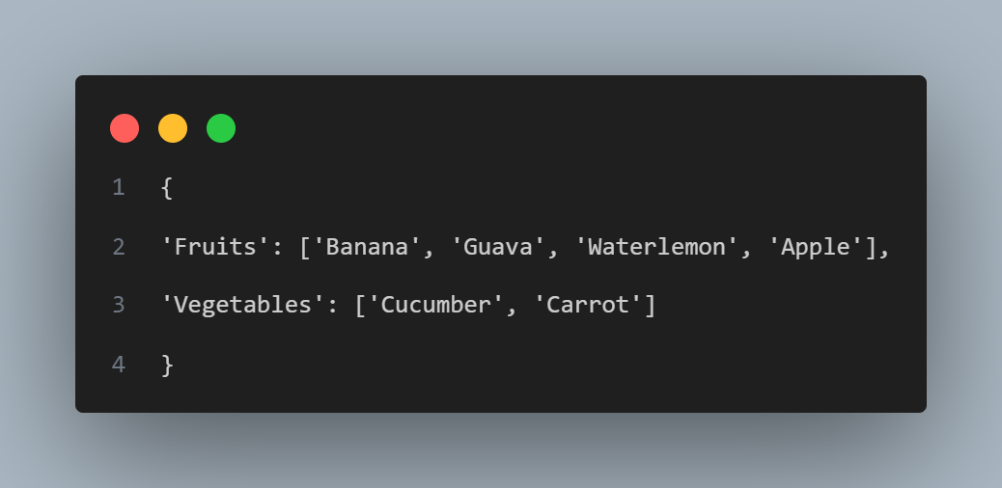

**Fig 1 Code Output *(output_file.txt)***

This code reads data from an input file named "input_file.txt" as instructed from the assignment, after reading the file it processes it to create an inverted dictionary, and then writes the inverted dictionary to an output file named "output_file.txt". Here's a breakdown of the code:

1. **with open("./files/input_file.txt") as file**: This line opens the input file named "input_file.txt" located in the "./files" directory using the `open()` function. The file is opened in read mode, and it is assigned to the file object `file`. The `with` statement is used to automatically close the file once the block of code inside it is executed as stated on our text book and video tutorial shown on my learning Guide .
2. **data = eval(file.read())**: This line reads the content of the input file using the `read()` method, which returns a string containing the file's contents. The `eval()` function is then used to evaluate the string as a Python expression as stated on Downey, A. (2015,). Think Python: How to think like a computer scientist ,*Chapter 7.9- iteration (pp 69)* , converting it into a dictionary object. This dictionary is assigned to the variable `data`.
3. **inverted_dict = dict():** This line initializes an empty dictionary named `inverted_dict`, which will store the inverted dictionary.
4. **for value in data:** This line iterates over the keys of the `data` dictionary. In this context, `value` represents each key in the dictionary.
5. **item = data[value]:** This line retrieves the value associated with the current key (`value`) from the `data` dictionary and assigns it to the variable `item`.
6. **`if item not in inverted_dict:`:** This line checks if the `item` (the value from the original dictionary) is not already a key in the `inverted_dict` (the inverted dictionary).
7. **`inverted_dict[item] = [value]`:** If the `item` is not already in the `inverted_dict`, a new key-value pair is added, where the key is `item`, and the value is a list containing the current key `value`.
8. **`else:`**: If the `item` is already in the `inverted_dict`, meaning there is already a key with that value, then this block of code is executed.
9. **`inverted_dict[item].append(value)`:** This line appends the current key `value` to the list of values associated with the key `item` in the `inverted_dict`
10. **`with open("./files/output_file.txt", "w") as file:`**: This line opens the output file named "output_file.txt" located in the "./files" directory using the `open()` function. The file is opened in write mode, and it is assigned to the file object `file`. Again, the `with` statement is used to automatically close the file once the block of code inside it is executed.
11. **`file.write(str(inverted_dict))`:** This line converts the `inverted_dict` dictionary into a string representation using the `str()` function and writes it to the output file using the `write()` method.

To summarize the whole points this code reads a dictionary from an input file, creates an inverted dictionary where the original dictionary's values become keys and vice versa, and then writes the inverted dictionary to an output file.

**References**

Downey, A. (2015,). Think Python: How to think like a computer scientist ,*Chapter 7.9- iteration (pp 69)*

<https://greenteapress.com/thinkpython2/thinkpython2.pdf>